Create payment

# Before starting with this document

Review ***Create token Instructions.doc***, that allows you have the following information needed to perform payments:

* Public-key
* Private-key
* app_id. (in this document we use **com.payu.colombia.testbusinessunit**)

Due to this document will be in test environment, the field **x-payments-os-env** will be “test”

# Perform payment

To perform a payment please refer to PayU-SETest/Perform payment.

Add parameters **app_id** and **public_key** according to ***Create token Instructions.doc***. You can use sample data in body or edit according to your test.

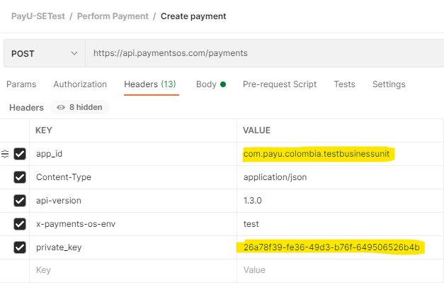

In request you can edit body, where you can change the amount, currency, billing information and order details.

{

  "amount": 4097,

  "currency": "EUR",

  "billing_address": {

    "phone": "+1-541-754-3010"

  },

  "order": {

    "id": "myorderid"

  }

}

In response you will receive an id of your transaction, that you will use for authorize, refund, and capture.

{

    "id": "f34bef28-a9b4-4bc3-92db-97bc134f2363",

    "currency": "EUR",

    "created": "1614620819873",

    "modified": "1614620819873",

    "is_chargedback": **false**,

    "status": "Initialized",

    "billing_address": {

        "phone": "+1-541-754-3010"

    },

    "possible_next_actions": [

        {

            "action": "Credit",

            "href": "https://api.paymentsos.com/payments/f34bef28-a9b4-4bc3-92db-97bc134f2363/credits"

        },

        {

            "action": "Charge",

            "href": "https://api.paymentsos.com/payments/f34bef28-a9b4-4bc3-92db-97bc134f2363/charges"

        },

        {

            "action": "Authorization",

            "href": "https://api.paymentsos.com/payments/f34bef28-a9b4-4bc3-92db-97bc134f2363/authorizations"

        },

        {

            "action": "Update Payment",

            "href": "https://api.paymentsos.com/payments/f34bef28-a9b4-4bc3-92db-97bc134f2363"

        },

        {

            "action": "Authentication",

            "href": "https://api.paymentsos.com/payments/f34bef28-a9b4-4bc3-92db-97bc134f2363/authentications"

        },

        {

            "action": "Risk analysis",

            "href": "https://api.paymentsos.com/payments/f34bef28-a9b4-4bc3-92db-97bc134f2363/risk-analyses"

        }

    ],

    "order": {

        "id": "myorderid"

    },

    "amount": 4097

}

The most important fields we will use for payments will be:

    "id": "f34bef28-a9b4-4bc3-92db-97bc134f2363",